1st Step Delete everything from the .m2 folder **IF ONE EXISTS.**If one exists it should be under c:\ntniid\.m2

2 Open Eclipse

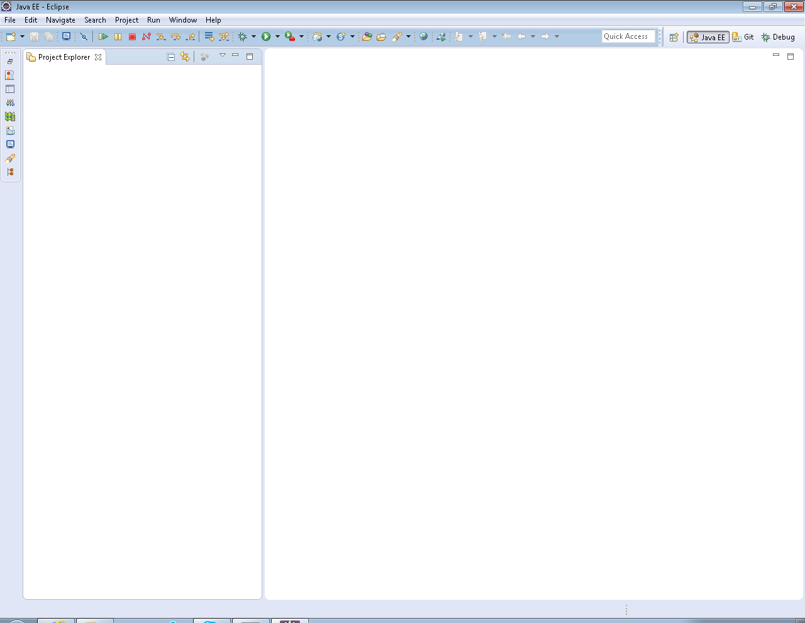

3 Navigate to Window🡪Show View🡪Other🡪

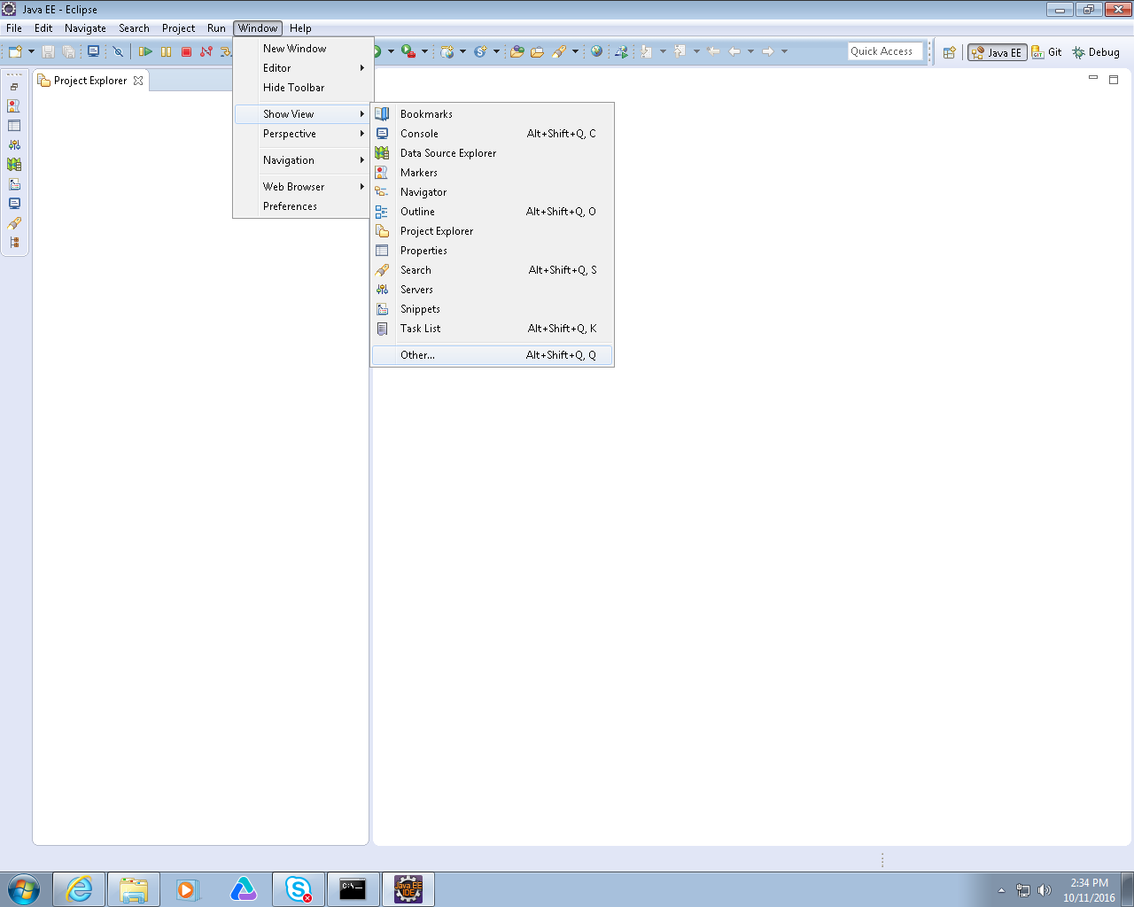

4 Select Other. Then navigate to Git🡪Git Repositories

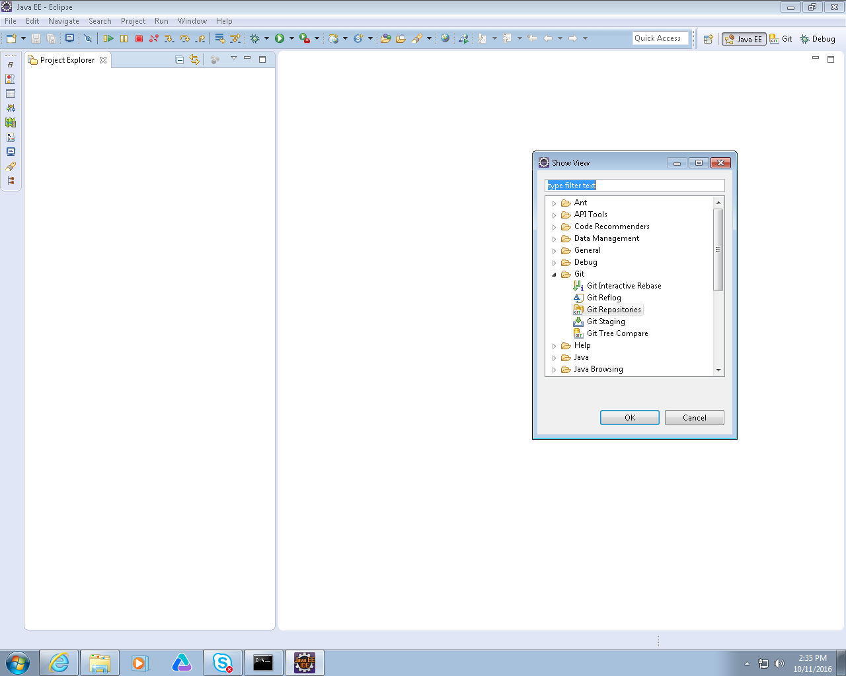

5 Click the Clone a Git repository link

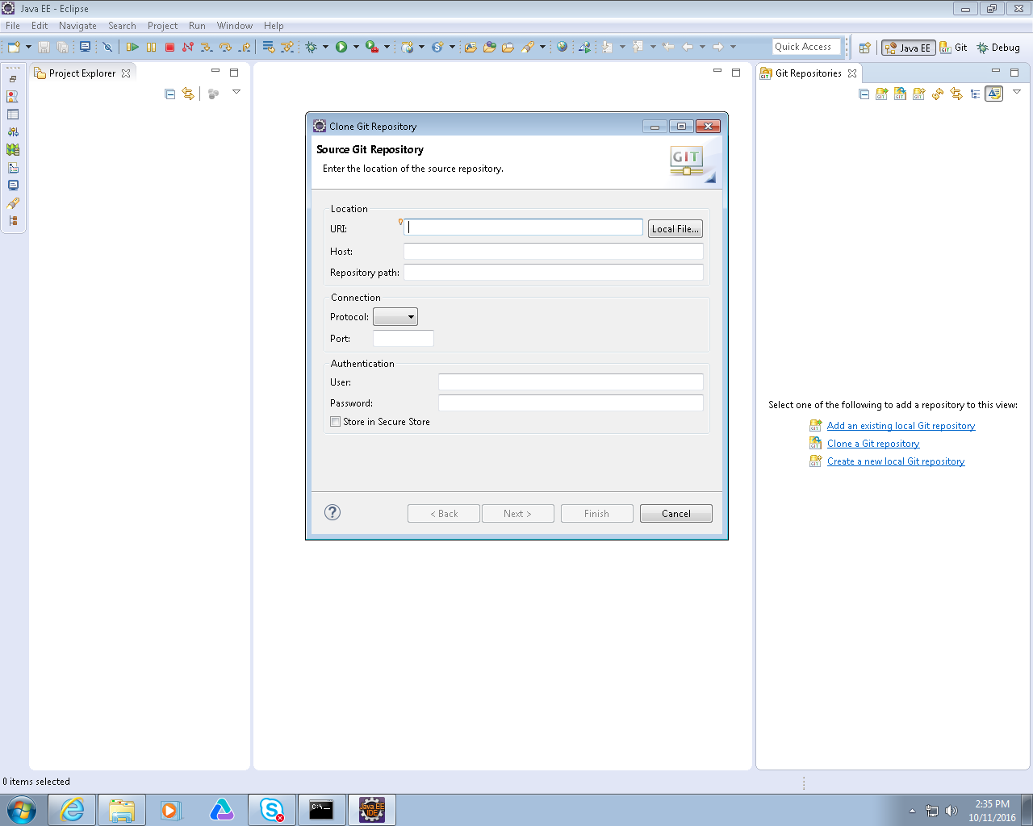

6 Enter the url <https://github.allstate.com/pkate/MasterApp_Automation.git> into the URI: field

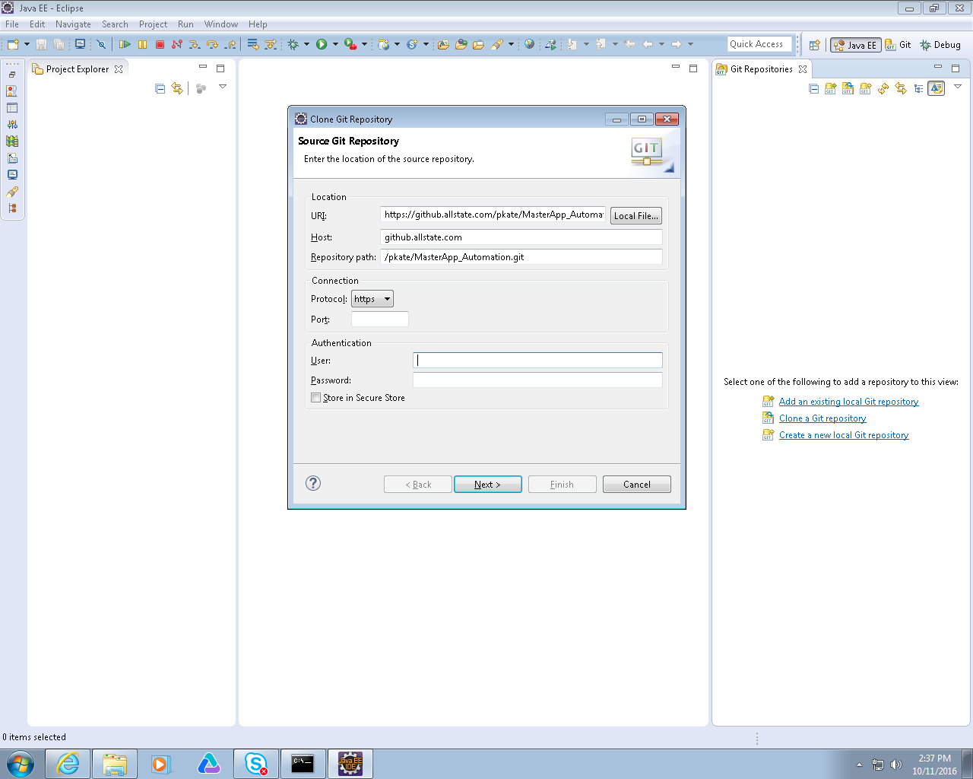

Enter your user name and password into the required fields and click the ‘Store in Secure Store’ check box.

Then click next

7 When Branch selection is displayed. Click the Deselect all button. Then just select the master branch as below

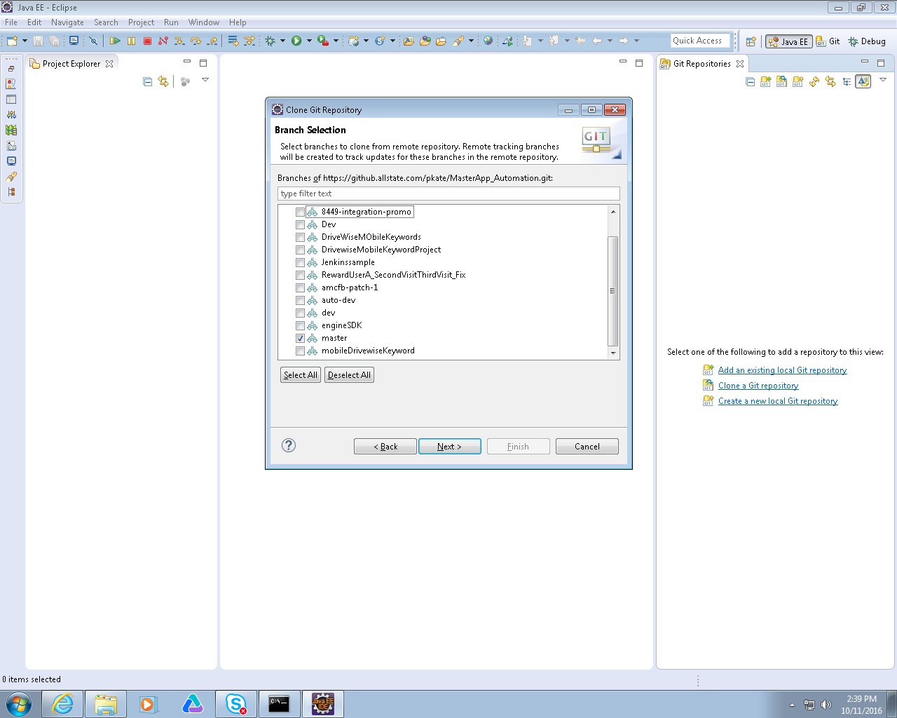

Click Next

8 Select a directory for the project to be cloned too. Eg c:\users\porou\git

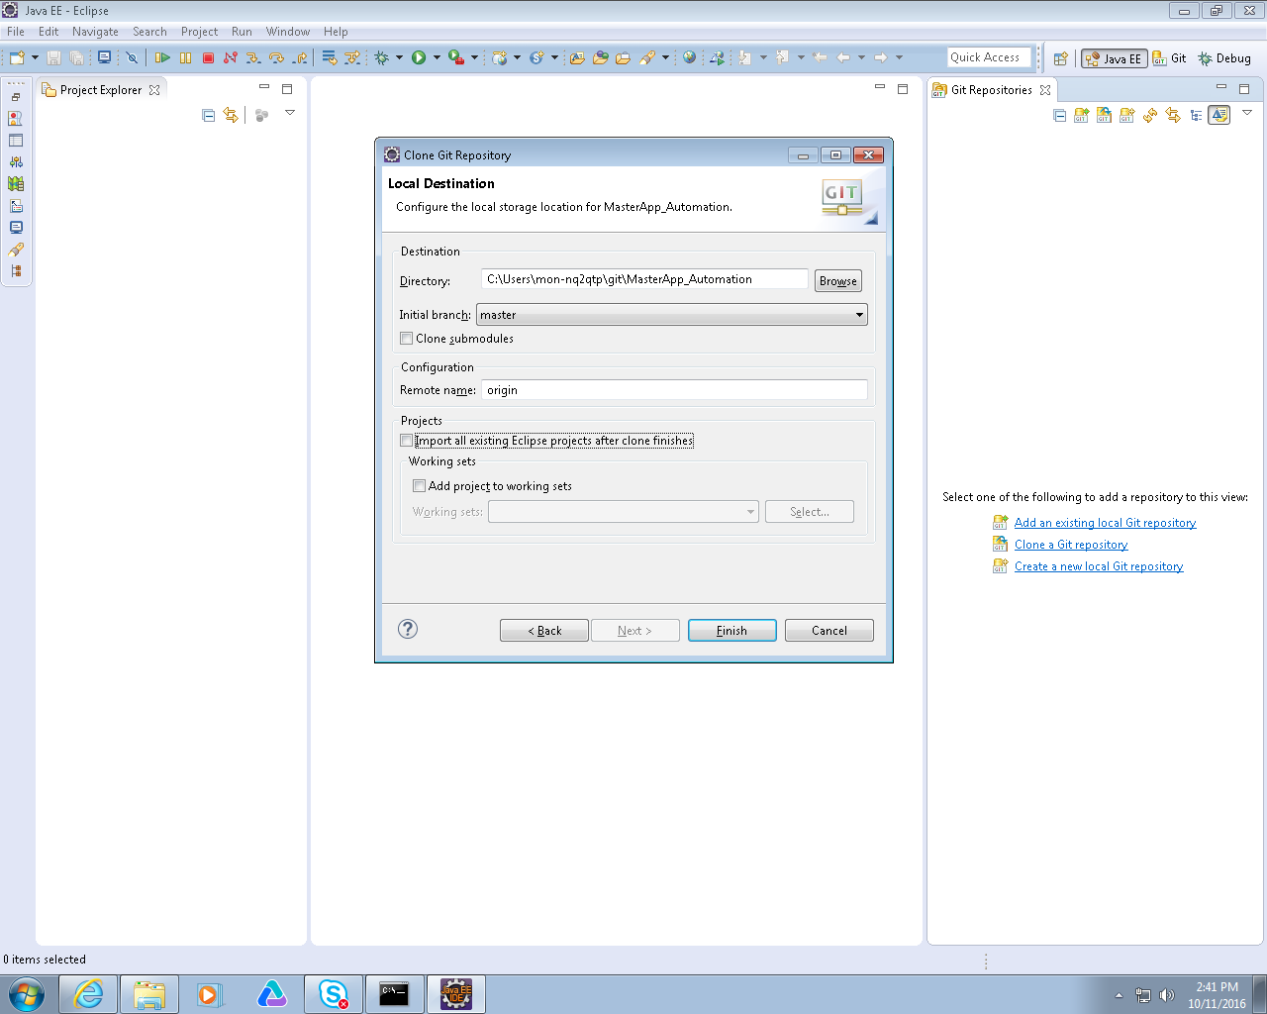

Click Finish

9 Project should clone

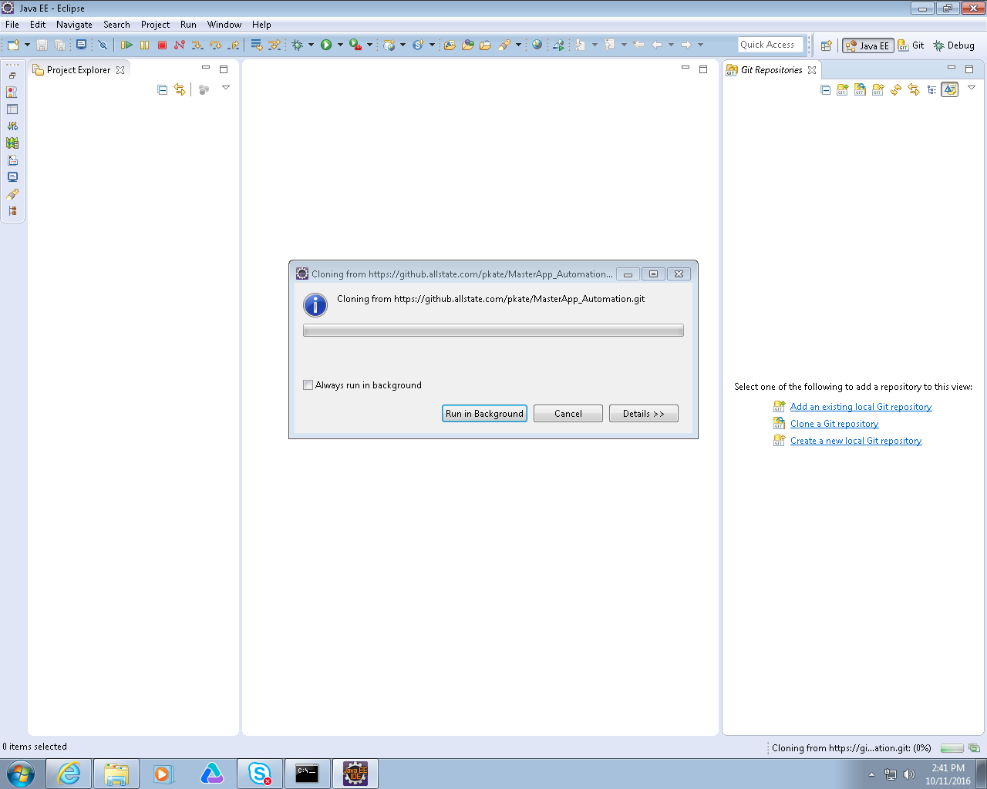

10 When is it finished you will see MasterApp_Automation in your git repositories panel.

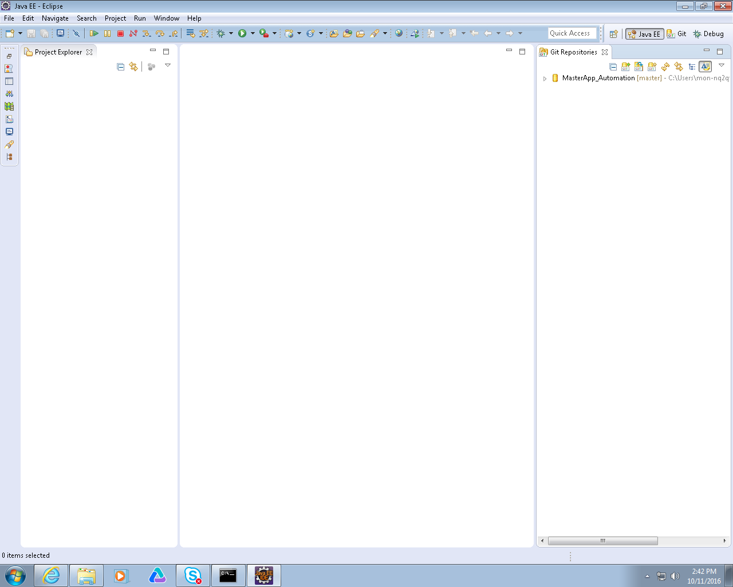

11 Right click on the MasterApp_Automation repository and select the Import Projects option

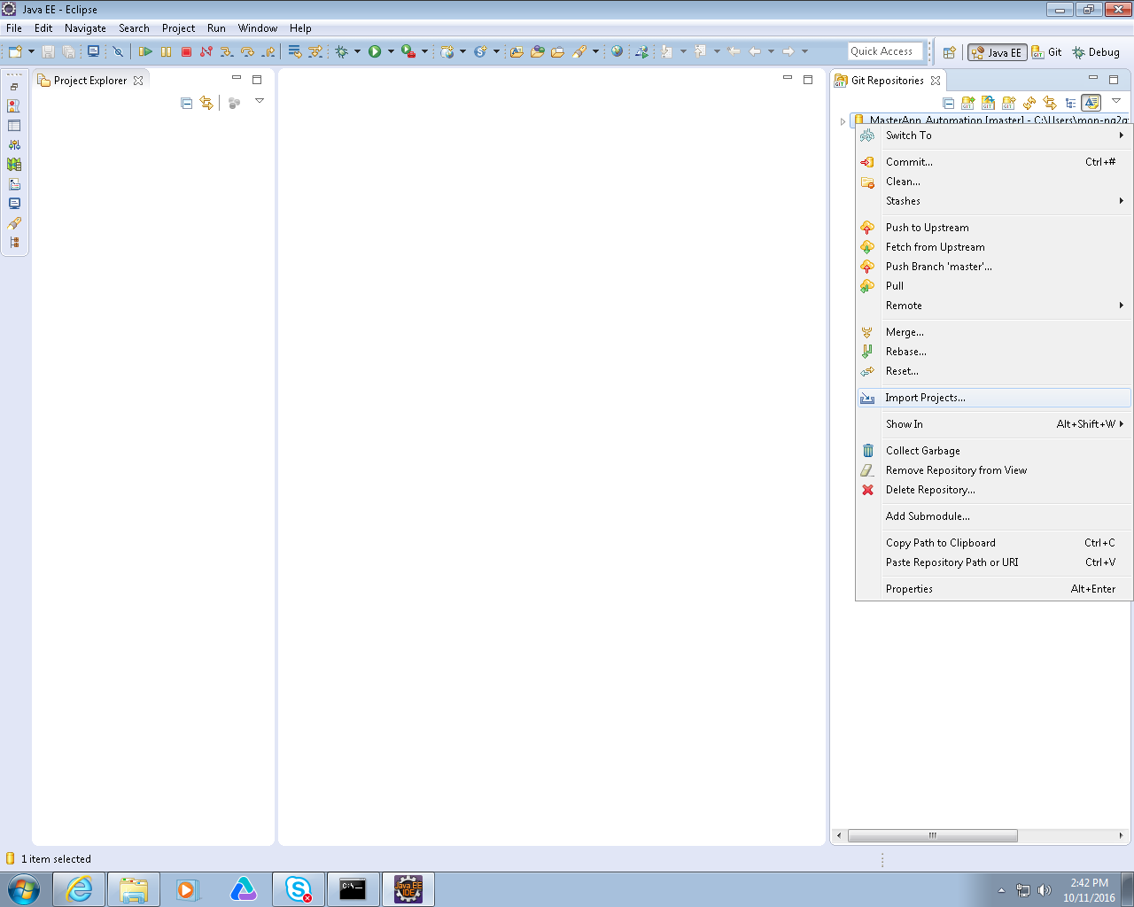

12 Select the AS-TestDriver project and click next

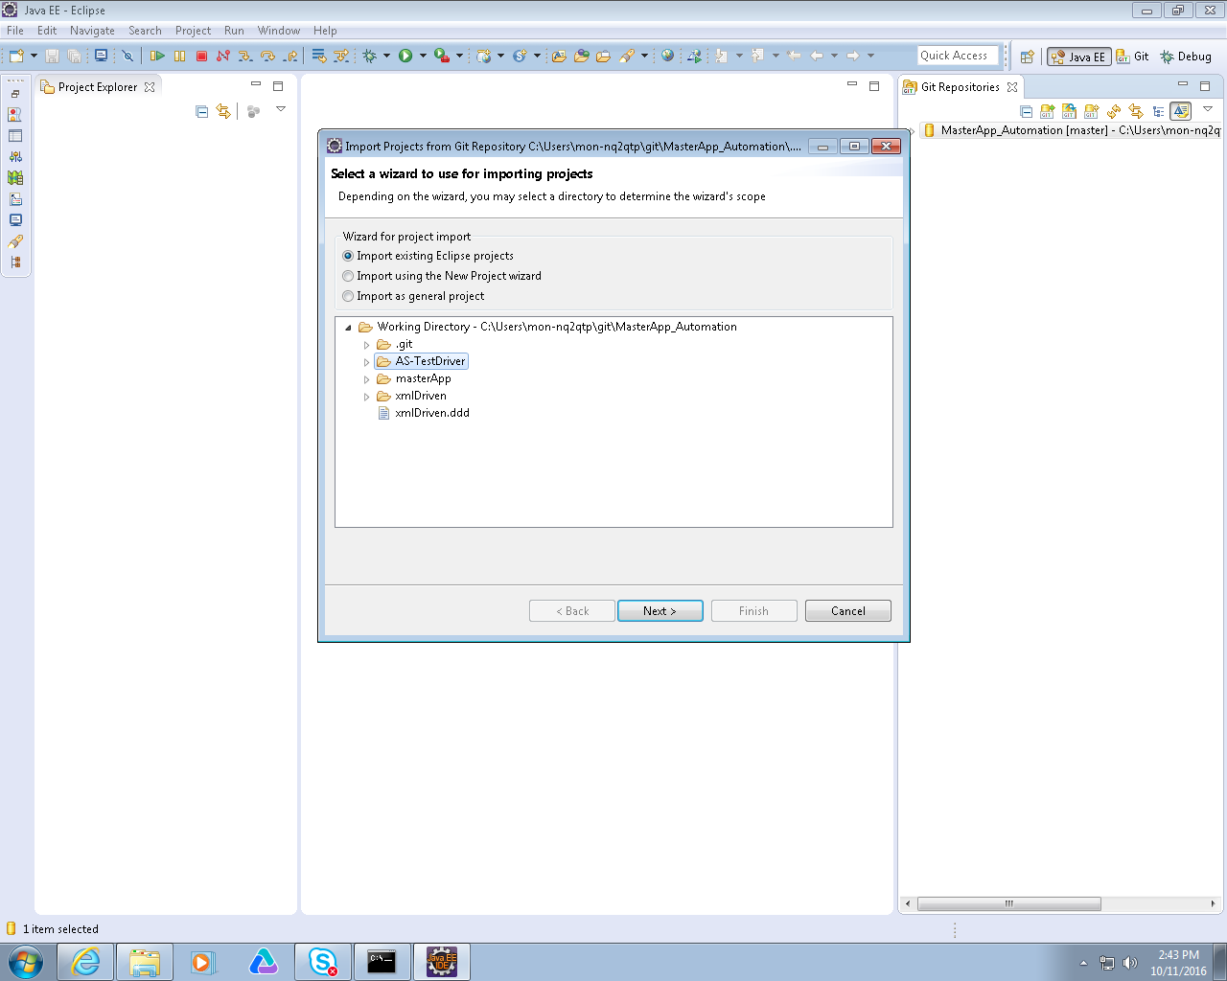

13 Ensure that the AS-TestDriver project is checked and click finish

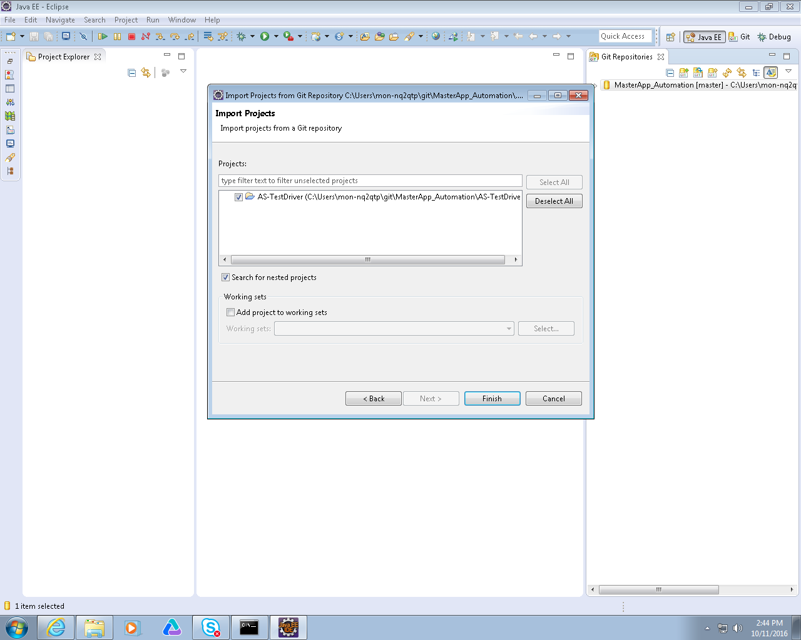

14 Project should start to build the workspace

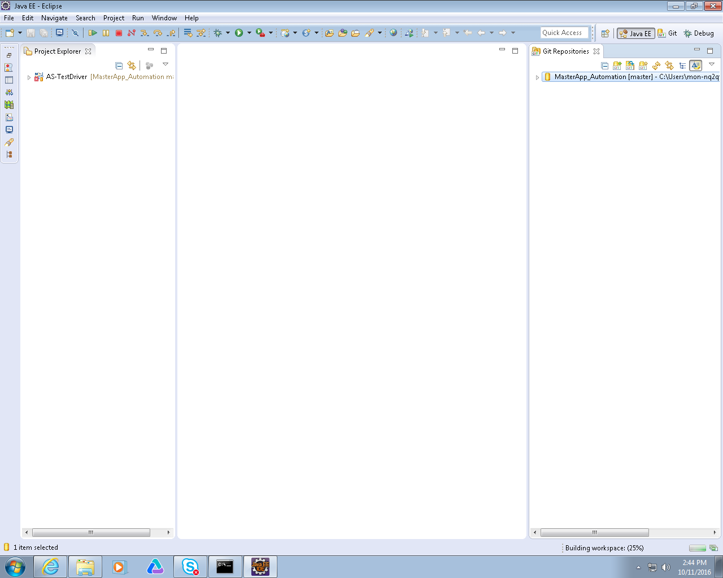

15 During this build process you may get the error below

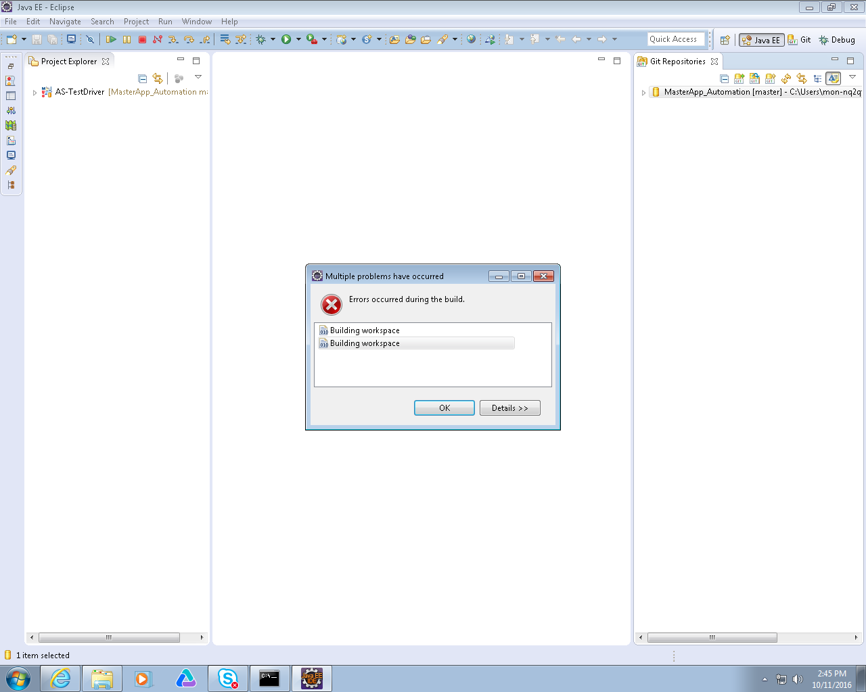

16 If you get this error copy the file settings.xml to the .m2 folder.

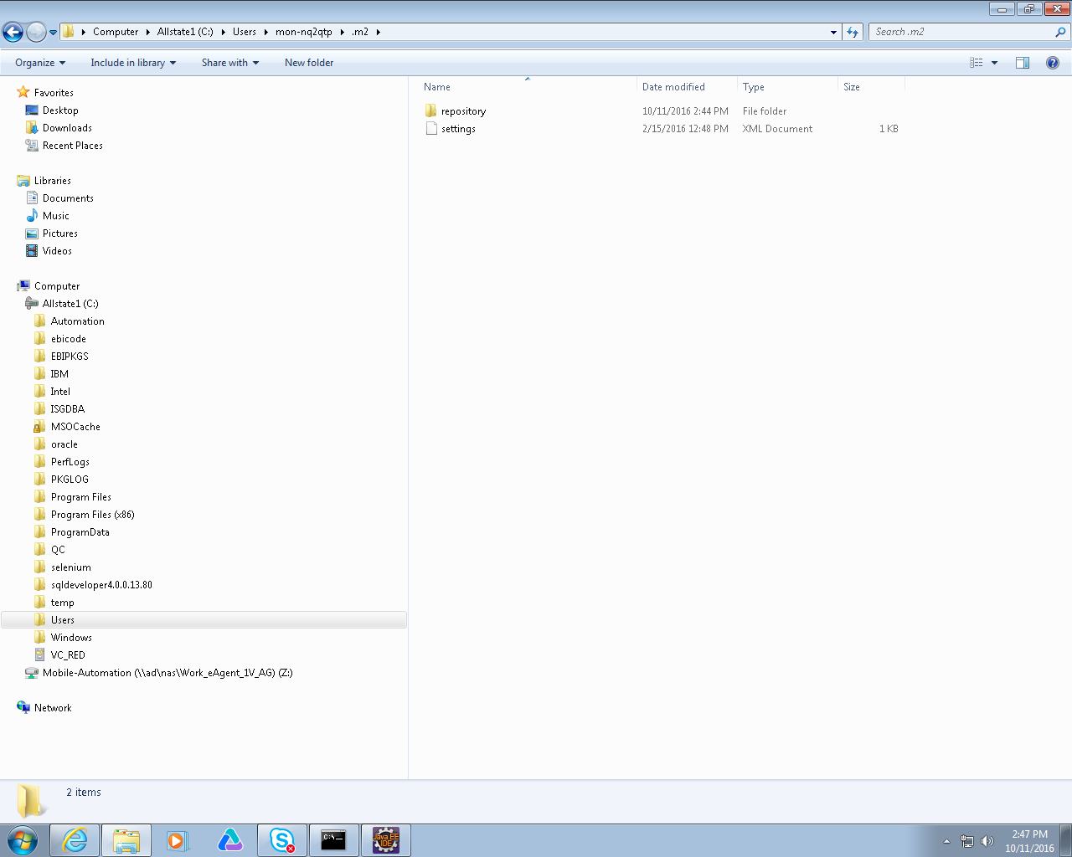

**(Mac Users)**

.m2 folder is in your home / user folder  
  
Navigate to Finder  
Click Go   
Click Go to Folder  
Search for ~/.m2  
  
Sometimes the .m2 folder is hidden.  
  
If it is hidden, open Terminal and enter:  
  
mv ~/.m2 ~/m2  
ln -s ~/m2 ~/.m2  
  
This should make it unhidden

17 Open the POM.XML file in the as-testdriver project. Click on the pom.xml tab. Update the xframium-java and the xframium-driver versions from to 1.0.15b if not already at this version

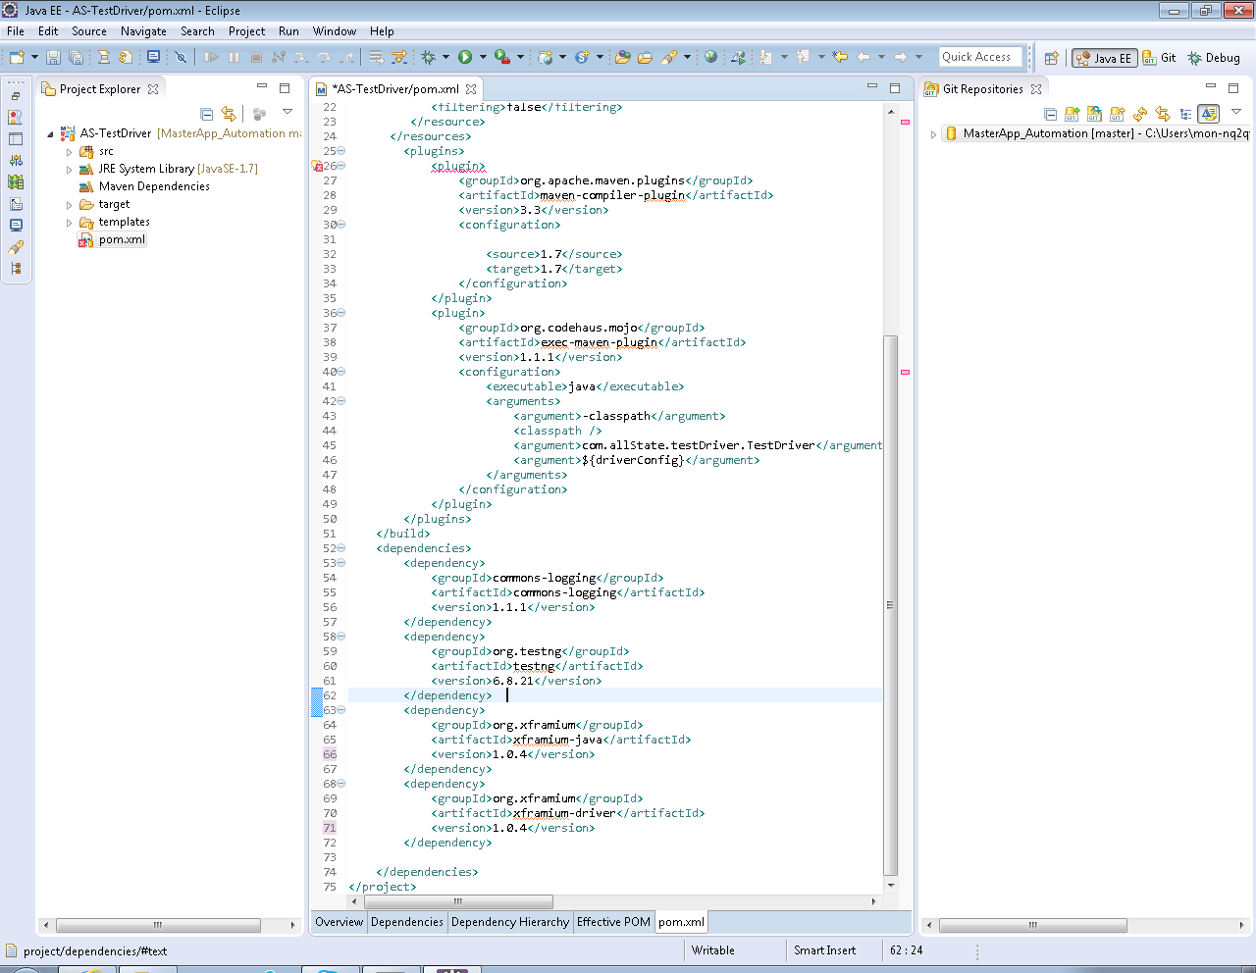

Click Save. As soon as you click save the project will start to build again.

18 Project Building. Allow the project to complete building. This can take some time

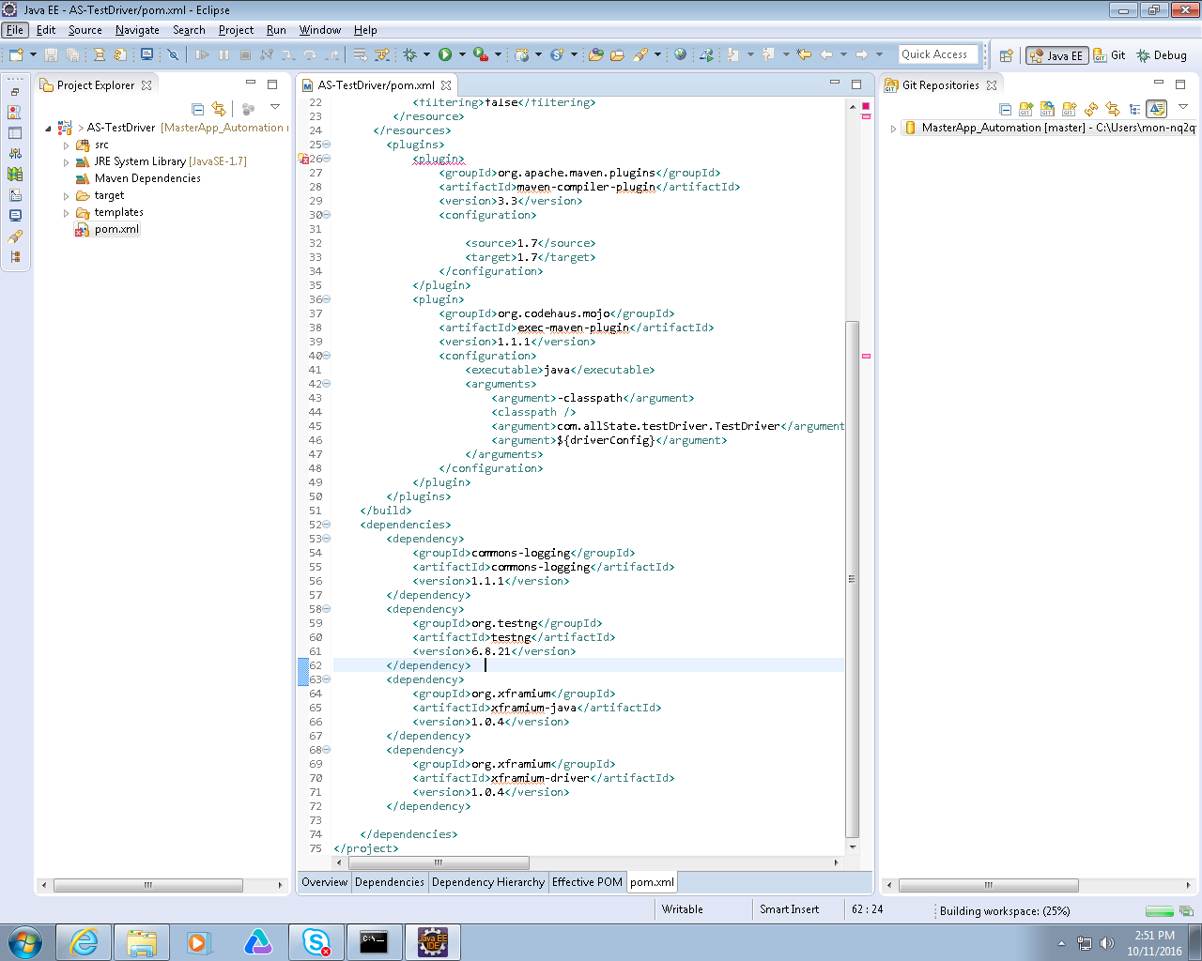

19 The build error may be displayed again. If it is Click OK.

Right click on the AS-TestDriver project and select Maven🡪Update Project

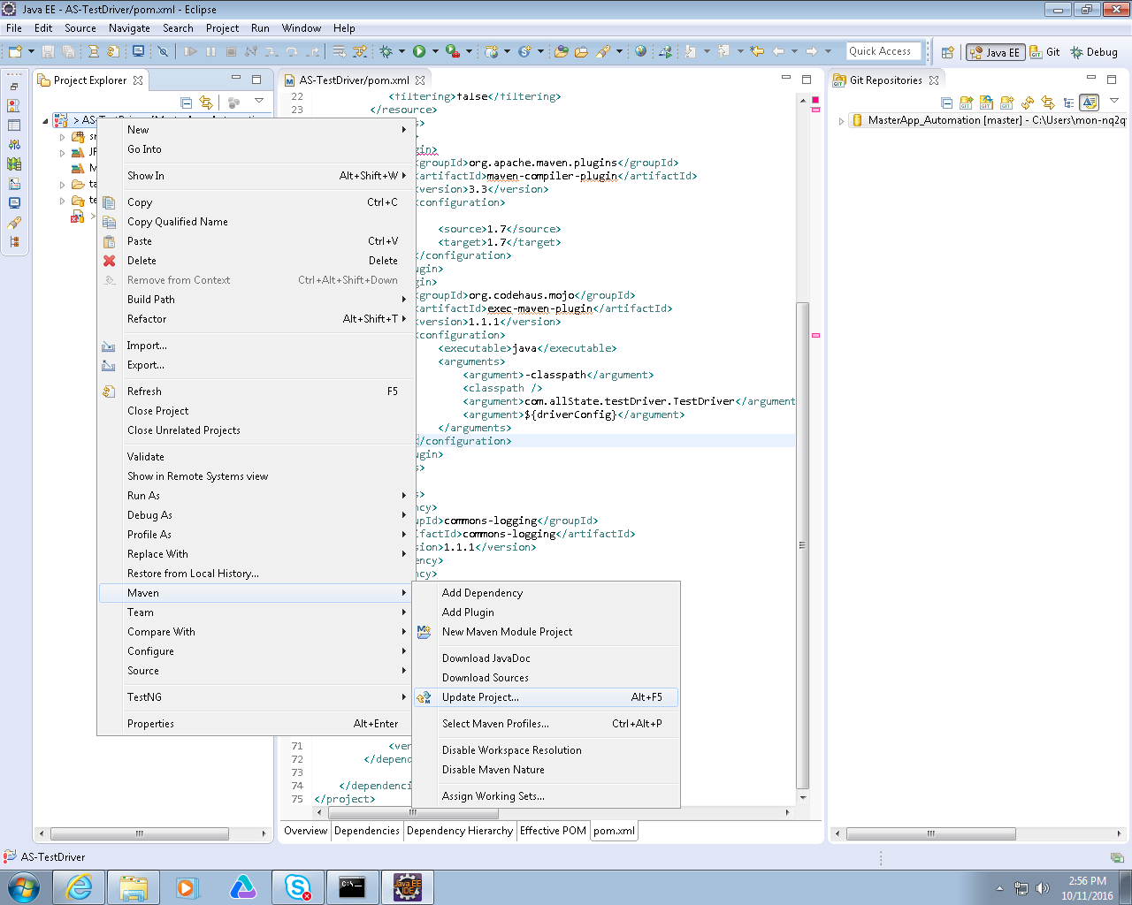

20 Check the Force Update of Snapshots/Release checkbox and click ok

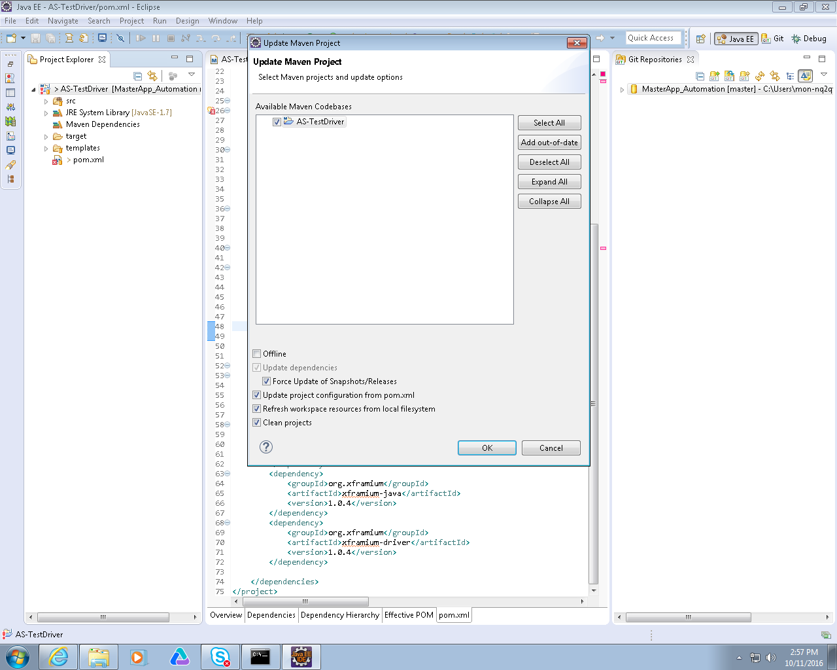

21 Maven Project will be updated

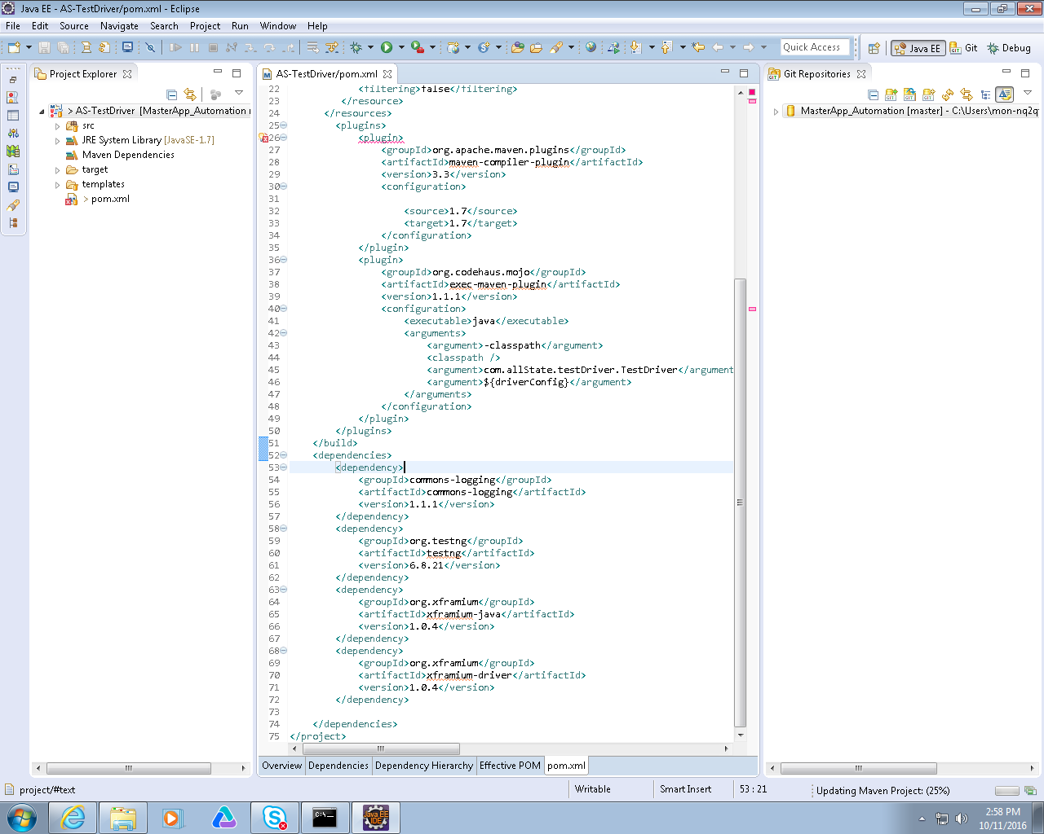

81 Errors

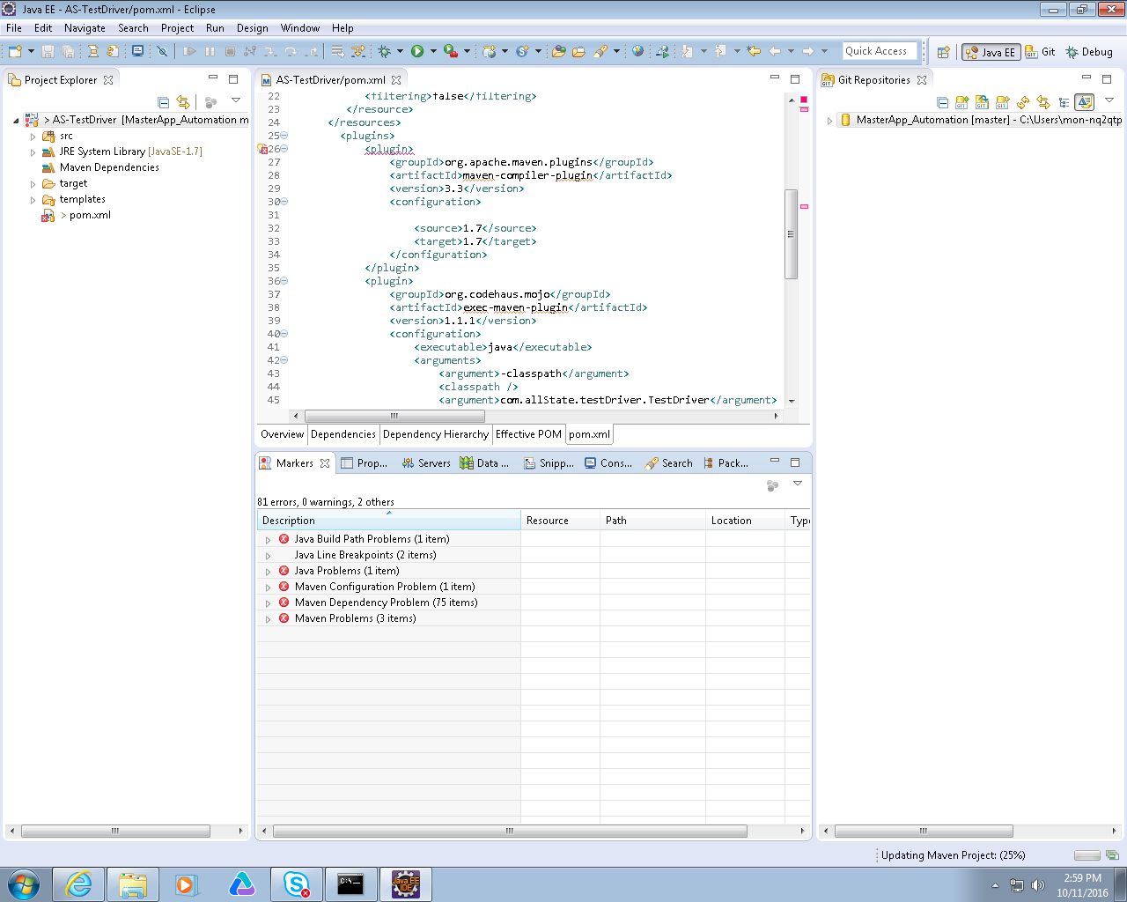

22 As Maven updates number of errors should be reduced to 0 when maven update completes. Warnings are ok

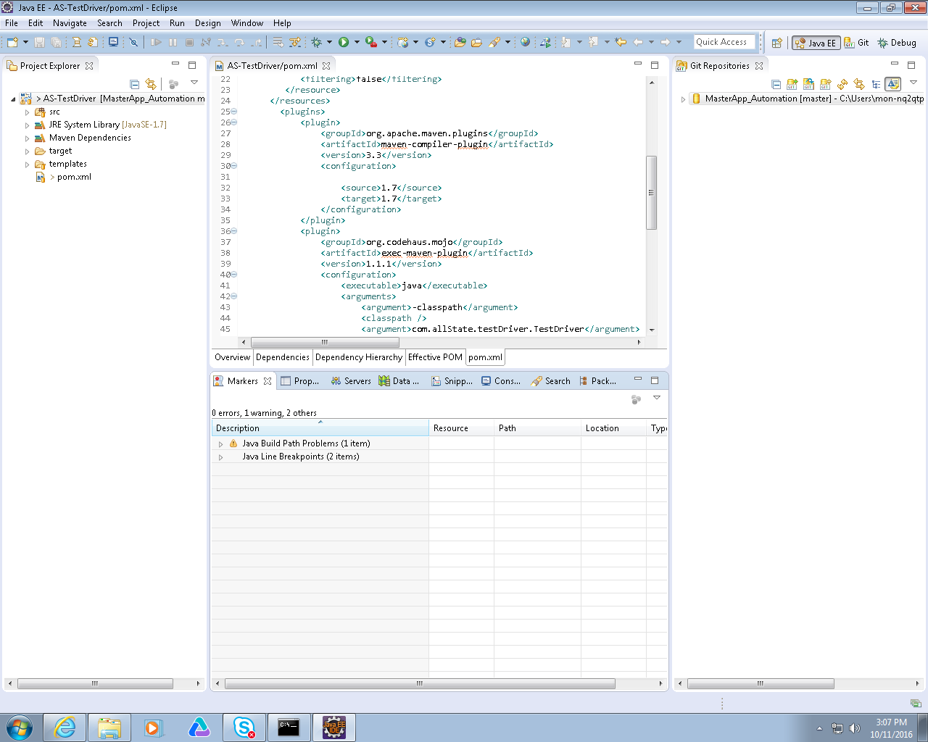

23 Right click on the github repository and select import projects

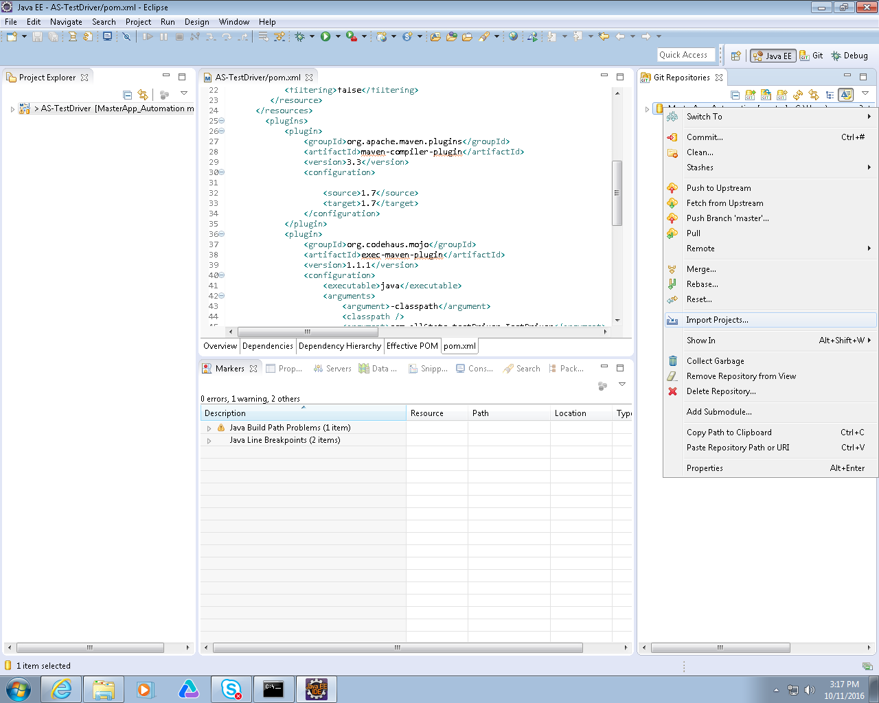

24 Select xmlDriven and click next

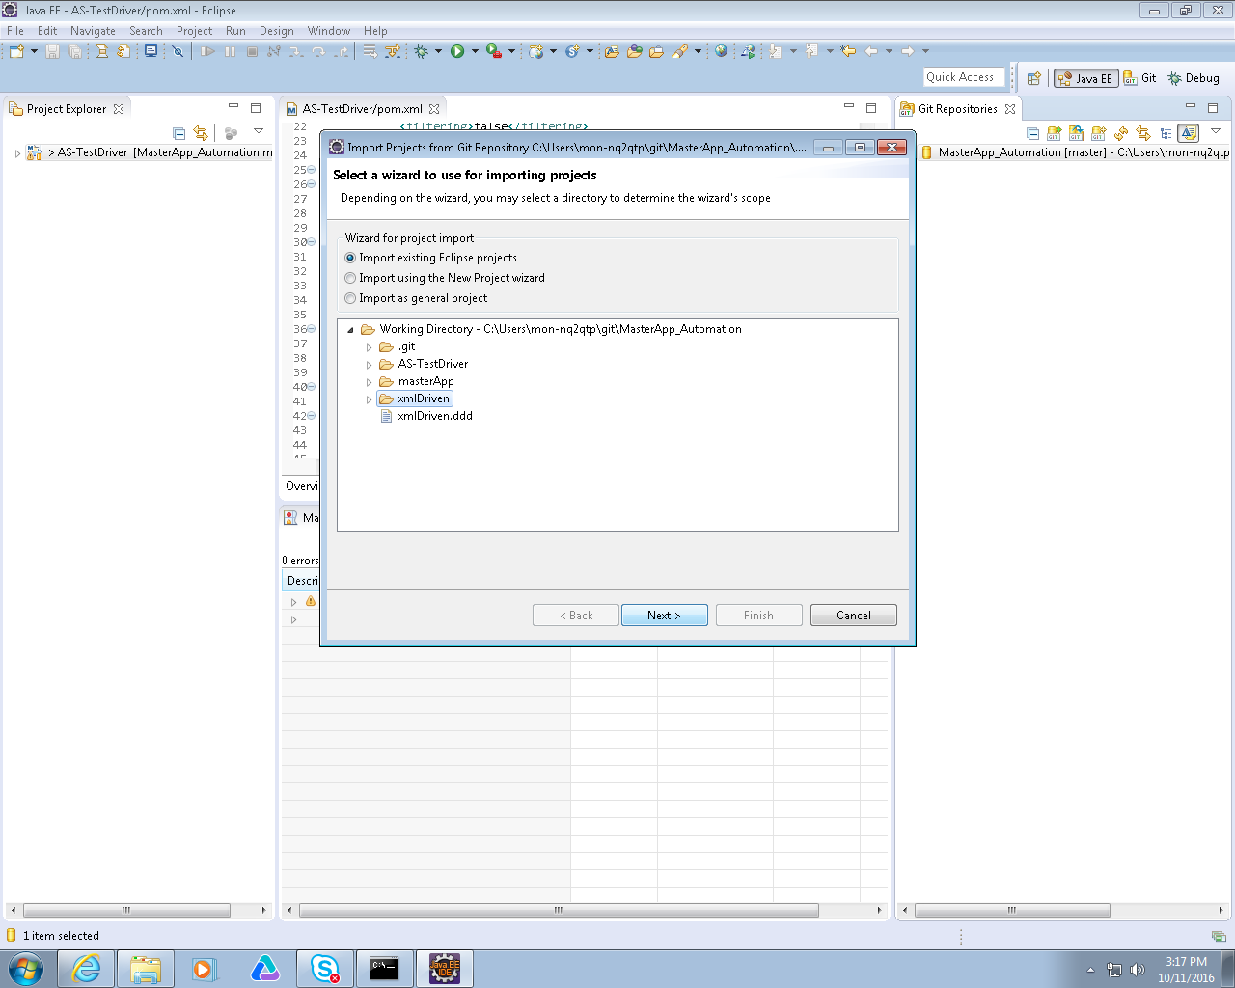

25 Ensure that xmlDriven is checked and click finish

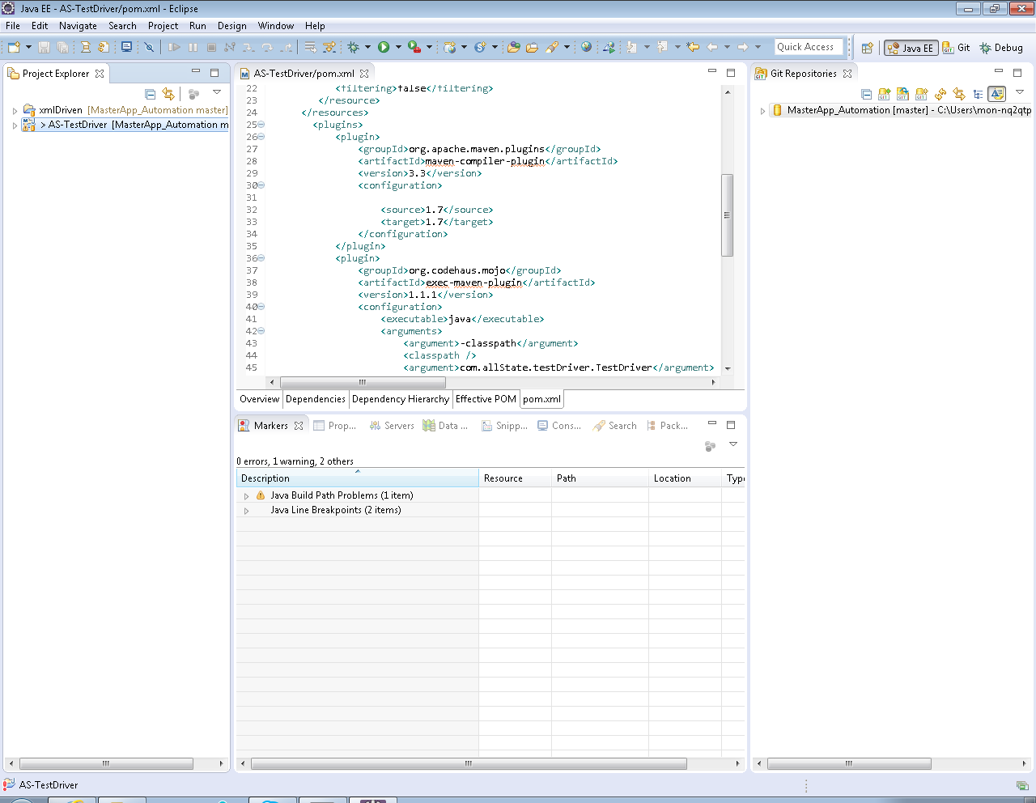

xmlDriven and AS-Testdriver projects should be present in your workspace.

26 Expand the AS-TestDriver project navigate to src🡪com.allState.testDriver. Right click on the TestDriver.Java file and select Run As🡪 Run Configurations

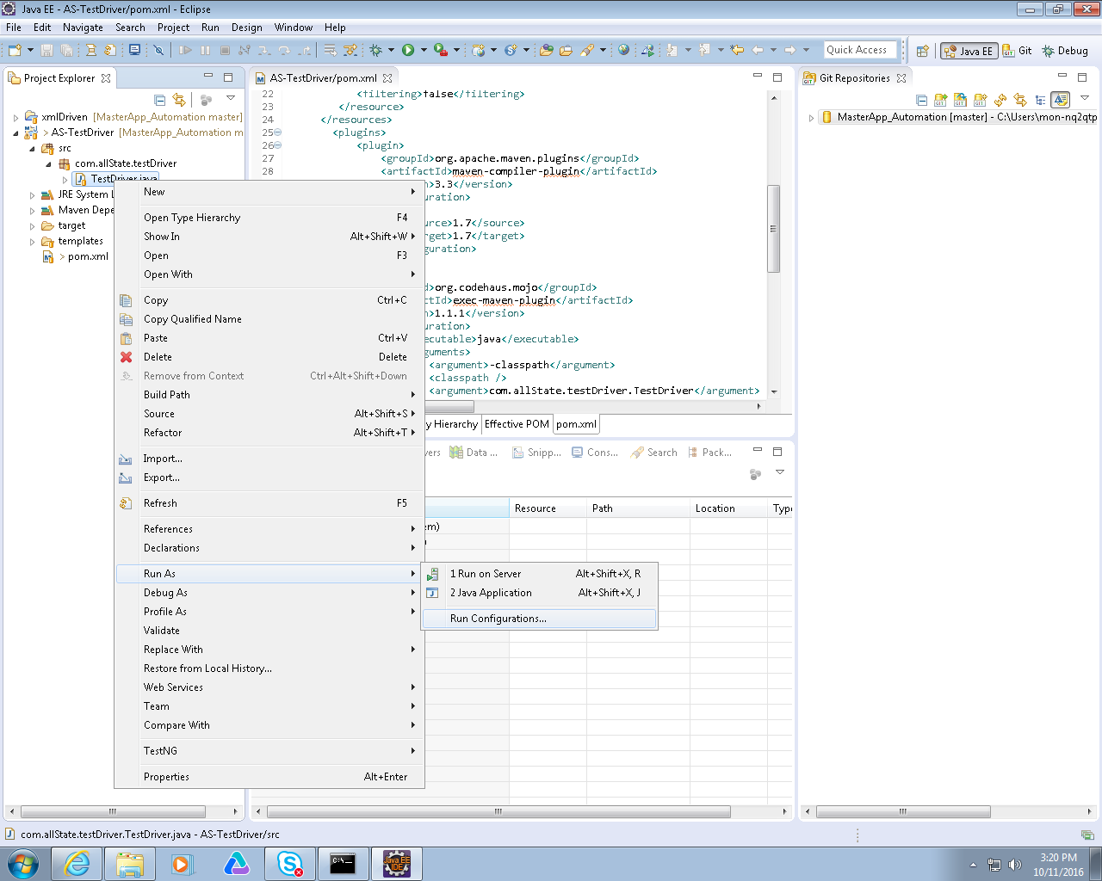

27 Select Java Application and Click the new Icon. Give the Configuration a name ie ETRM_Automation. Click Apply🡪Close

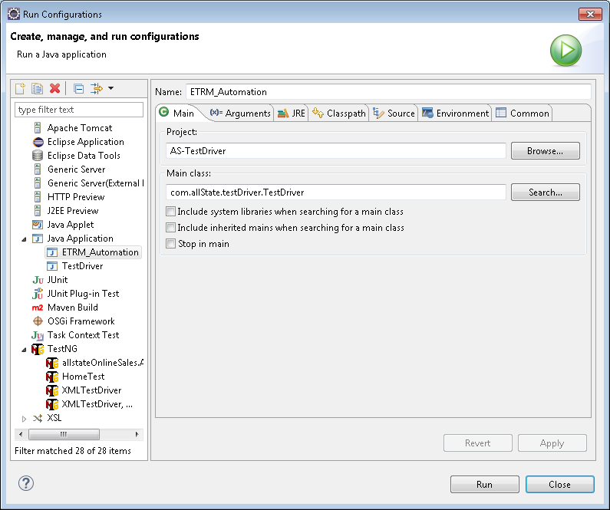

Done!